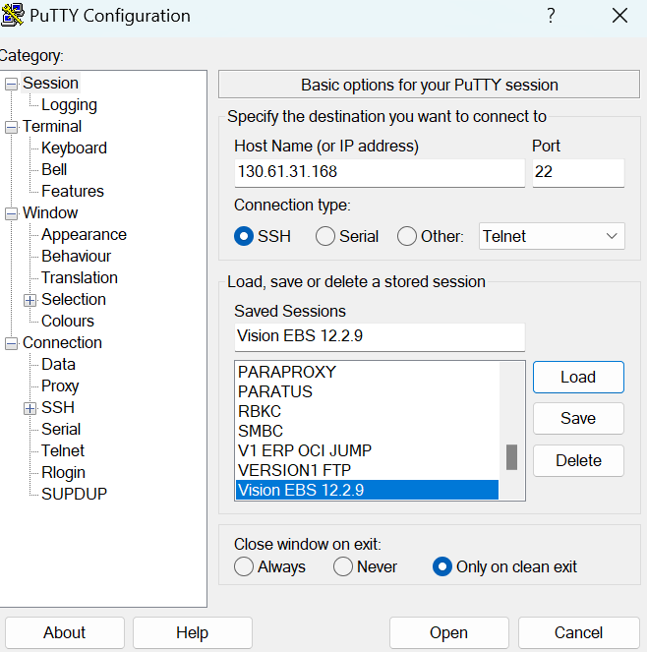



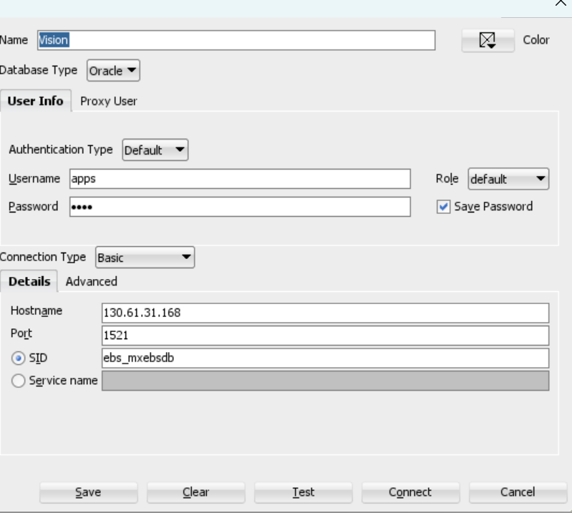

<http://vision1228mxdm.example.com:8000/>

CMOORE/ welcome

Login to Putty using opc

sudo su – oracle

cd /u01/install/APPS/fs2/EBSapps/appl

[oracle@vision1228mxdm appl]$ . mxebsdb_vision1228mxdm.env

[oracle@vision1228mxdm appl]$ . APPSmxebsdb_vision1228mxdm.env

$IAS_ORACLE_HOME/perl/bin/perl $FND_TOP/bin/irep_parser.pl -g -v -username=sysadmin fnd:patch/115/sql:XXMX_GL_PERIOD_STATUS_PKG.pls:12.0=/tmp/XXMX_GL_PERIOD_STATUS_PKG.pls

$FND_TOP/bin/FNDLOAD apps/apps 0 Y UPLOAD $FND_TOP/patch/115/import/wfirep.lct XXMX_GL_PERIOD_STATUS_PKG_pls.ildt

WINSCP

